**📚 Library System – Java GUI Application**

**Course:** CSCI217

**Instructor:** Prof. Sameh A. Salem  
**Teaching Assistant:** Nada Salah Mamoun  
**Team Members:**

Mahmoud Farag 2301002115

Maysoun Hassan 231002243

Ahmed Medhat 231002142

Amina Mohsen 231002112

**1. Project Overview**

This project is a Java-based Library Management System featuring a user-friendly Graphical User Interface (GUI). It enables users to manage a virtual library by performing actions such as adding, removing, borrowing, returning, and searching for books. Users can also view the overall library status including borrow statistics.

The system demonstrates core object-oriented programming (OOP) principles such as encapsulation and modular design. Java Swing is used for GUI components, and ArrayList<Book> is used to store and manage the library records.

**2. Objectives**

* Apply OOP concepts in a real-world application.
* Design an intuitive and responsive GUI using Java Swing.
* Simulate basic library operations like adding, removing, searching, borrowing, returning and view state for books.
* Collaborate effectively as a team on a software development project.

**3. Features**

• Add Book

Users can add new books by providing a title and selecting one of the predefined categories.

• Remove Book

Remove a book using its unique ID, provided the book is not currently borrowed.

• Search Book

Searches for books by title and displays all matching results, including ID, category, and borrow status.

• Borrow Book

Allows users to borrow a book by entering its ID, borrow date, and number of days. The system validates date and borrowing status.

• Return Book

Returns a previously borrowed book using its ID. Borrowing information is cleared upon return.

• View Status

Displays all books in the library with their details and provides summary statistics of books per category and borrow status.

• Exit

Closes the application safely.

**4. Categories of Books**

Books can be assigned to one of the following categories:

* Biology
* Maths
* History
* Chemistry
* Politics

**5. GUI Design**

* Built with Java Swing components.
* The main interface (JFrame) includes seven operation buttons in a grid layout.
* Input/output handled using JOptionPane dialogs for ease of interaction.
* JTextArea inside a JScrollPane is used to display scrollable status reports.
* Layouts such as BorderLayout and GridLayout ensure proper organization of the interface.

**6. Data Structures**

* Books are stored in an ArrayList<Book>.
* Each Book object includes:
  + A unique auto-incremented ID
  + Name (String)
  + Category (String)
  + Borrow status (Boolean)
  + Borrow period (int) and borrow date (String), if currently borrowed.

**7. Testing and Output**

**7.1 Welcome Screen**  
When the program starts, a welcome image appears with a button saying, "Enter Library".

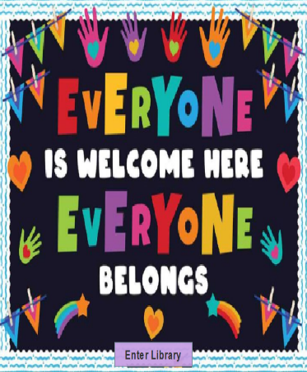

**7.2 Capacity Input**

After clicking "Enter Library", a box appears asking for the library capacity.

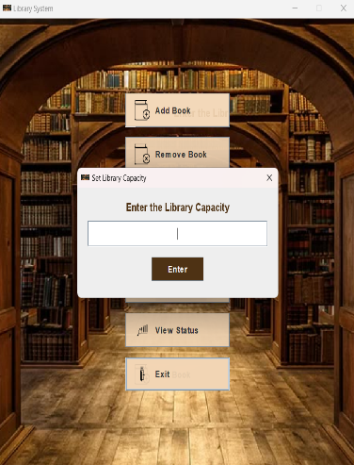

If user Enter invalid input program give it message

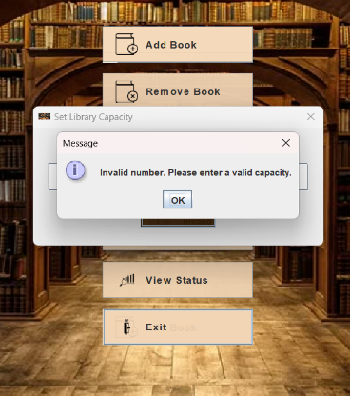

**7.3 Main Menu**

Once the capacity is set, the main window opens. It has buttons for all actions:

* Add Book
* Remove Book
* Search Book
* Borrow Book
* Return Book
* View Status
* Exit

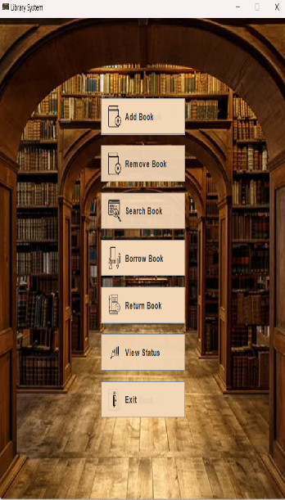

**7.4 Add Book**

* A box asks you to enter the book’s name.

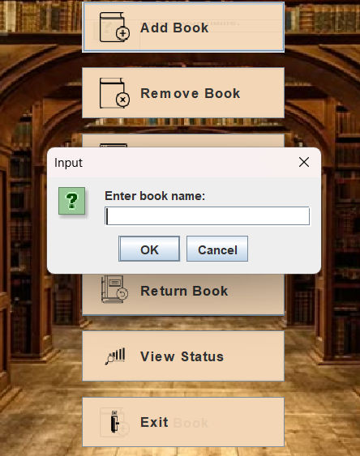

* Then you choose the category from a list.

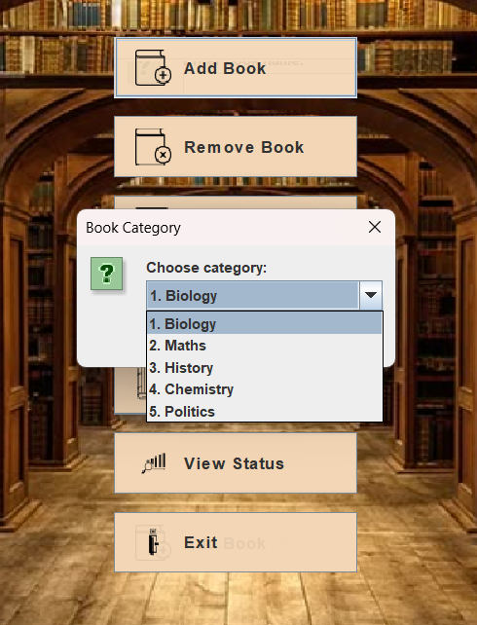

* The book is added to the library.

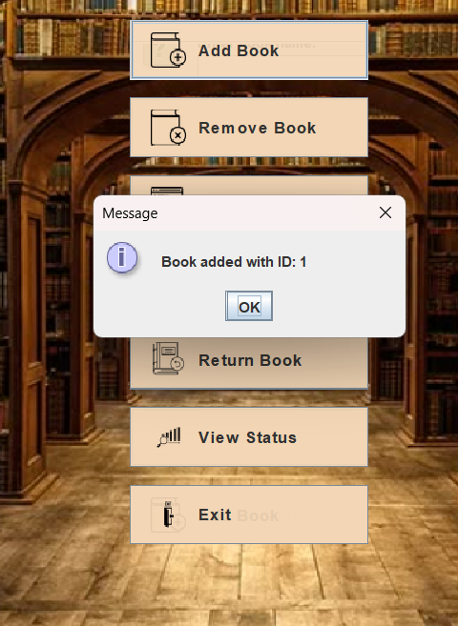

* If the library is full

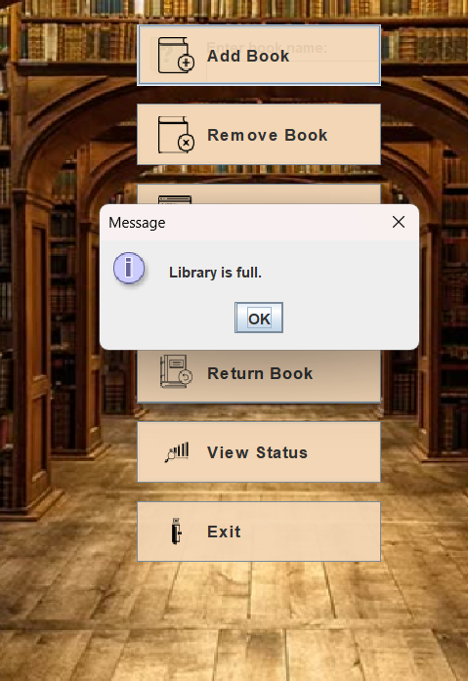

**8.5 Remove Book**

* A box asks for the book ID to remove.

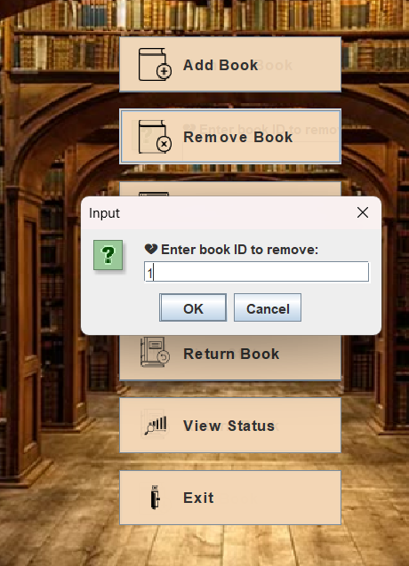

* If the book is not borrowed, it will be removed.

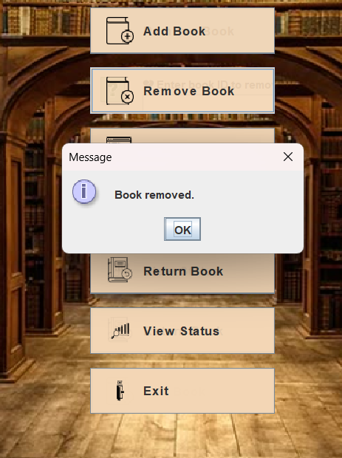

* If the book is borrowed, it shows a warning.

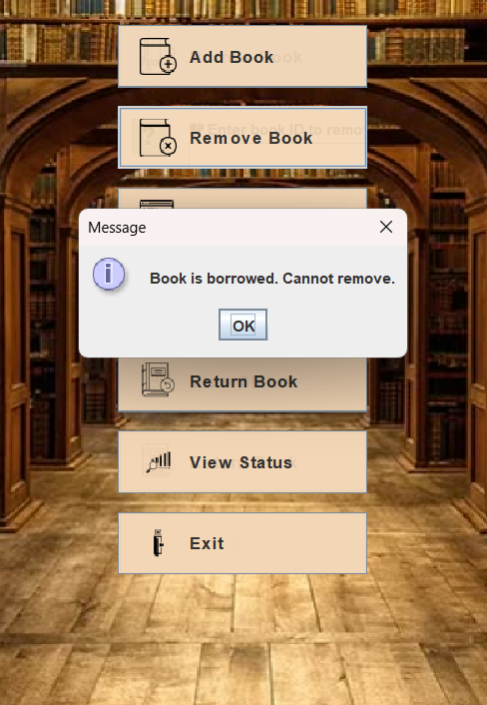

* If the ID is wrong, it shows an error.

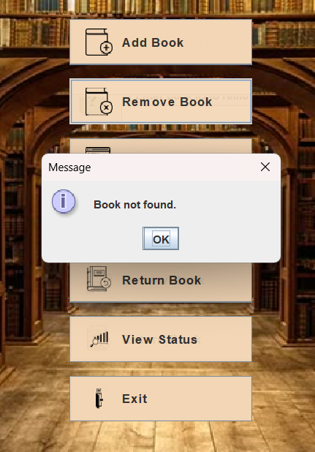

**7.5 Search for book**

* A box asks for the book name to search.

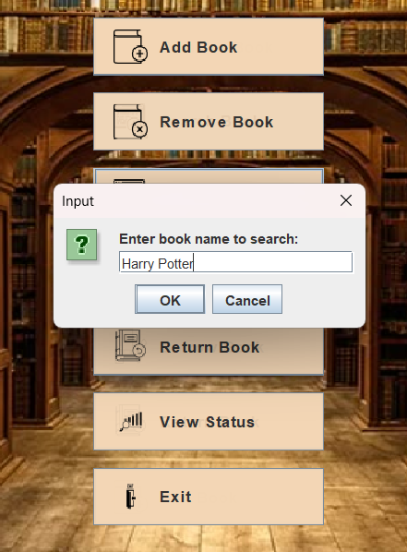

* It shows all matching books:

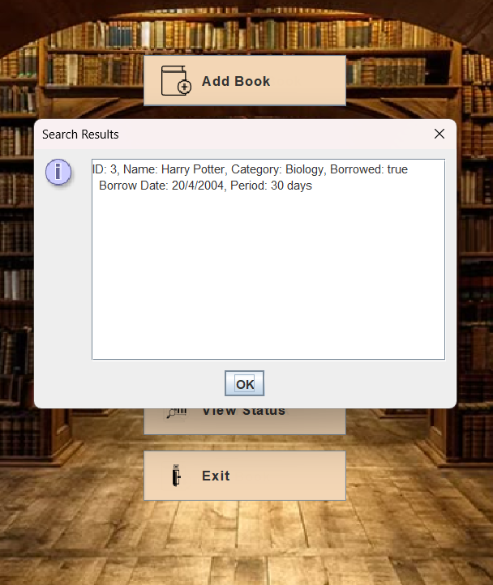

* If no match is found, a message is shown.

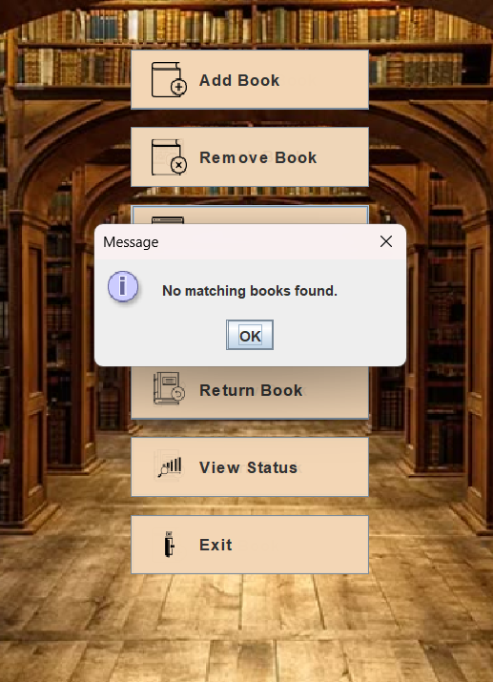

**7.6 Borrow Book**

* A box asks for the book ID.

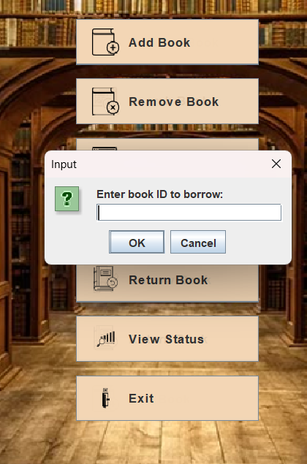

* Then ask for the number of days (max 30).

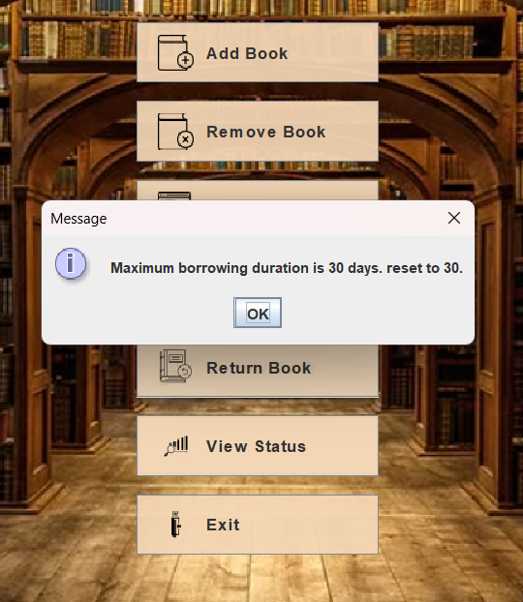

* Then asks for borrow date in format: dd/MM/yyyy.

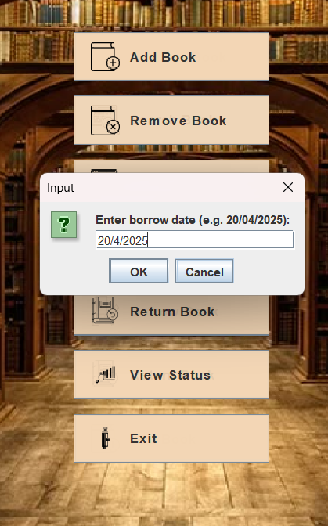

* If valid and available, the book is marked as borrowed.

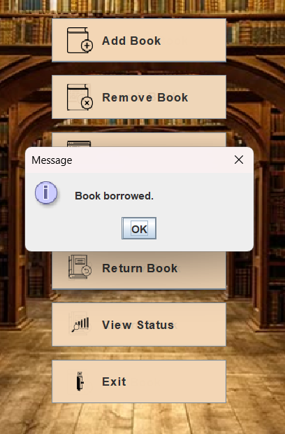

* ID is not found

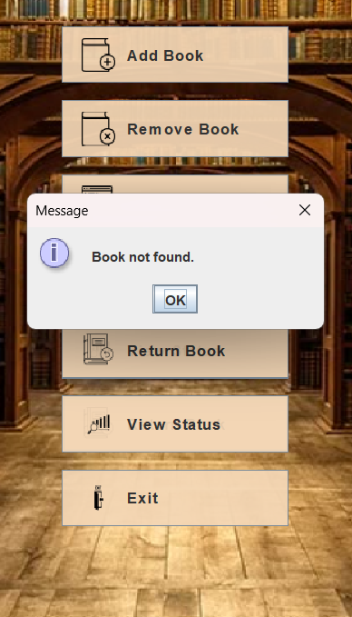

* The book is already borrowed

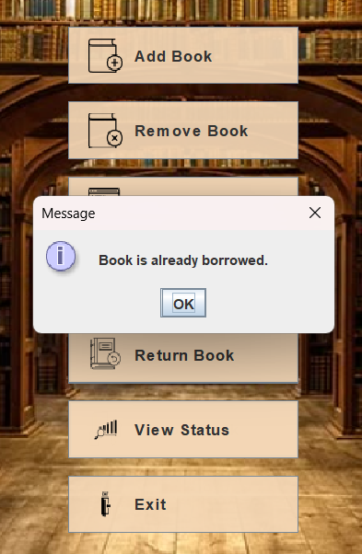

* Input is invalid

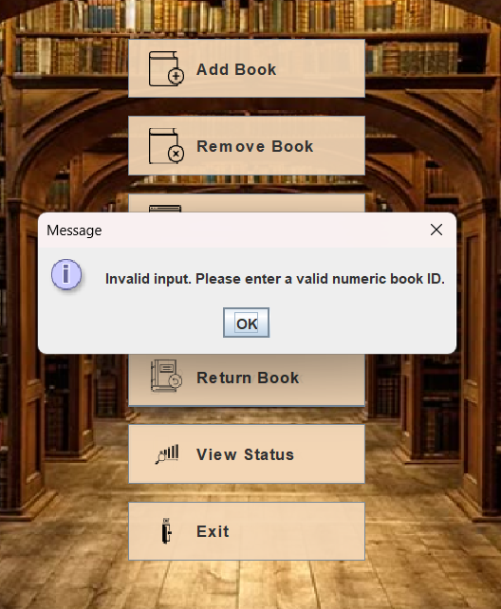

**7.7 Return Book**

* A box asks for the book ID to return.

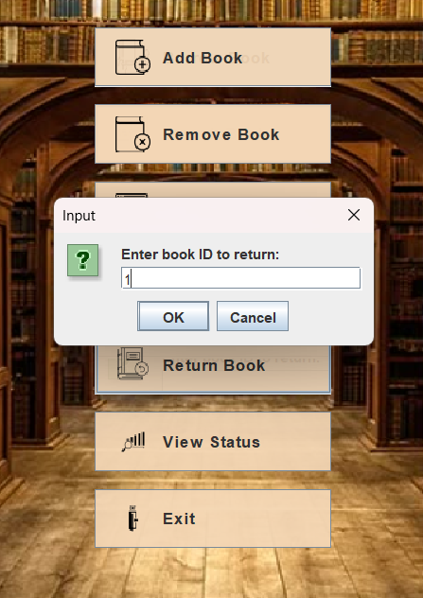

* If the book was borrowed, it is marked as returned.

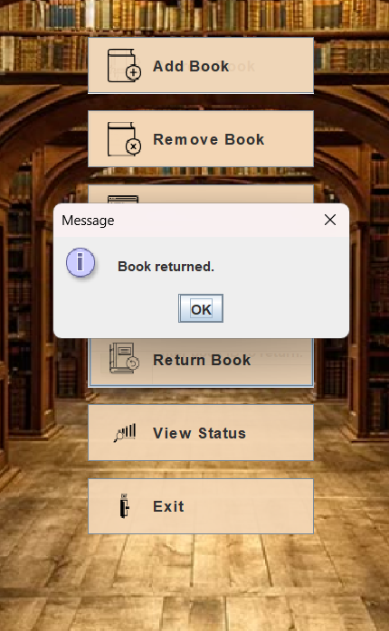

* Book is not borrowed

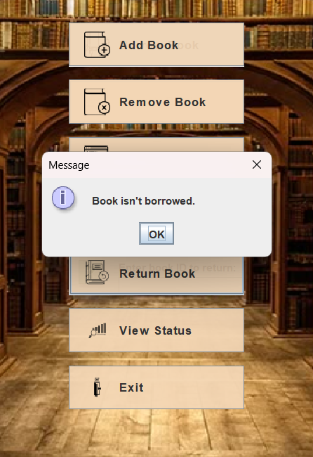

* Book ID not found

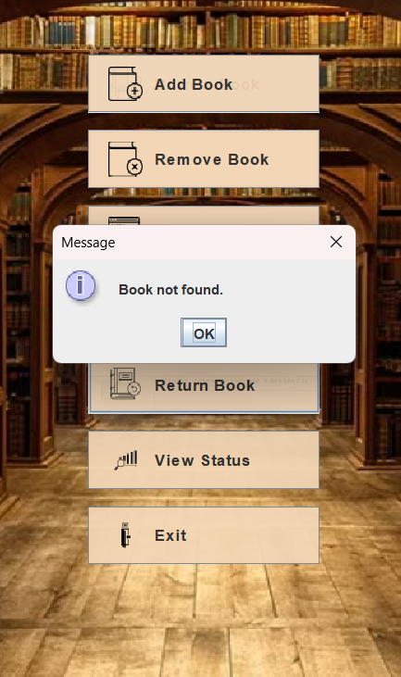

**7.9 View Status**

* Shows all books in the library with:

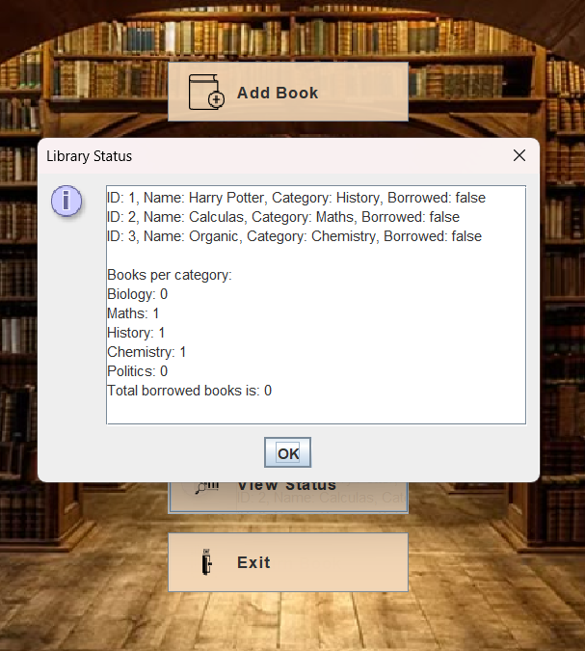

**8. Conclusion**

This project helped us understand how to use Java and GUI tools to build a real-world application. We practiced object-oriented programming and learned how to design a simple and useful interface. The Library System can add, remove, borrow, return, and search for books easily. It was a great learning experience for our team.